IRIS FLOWER CLASSIFICATION
Data set : https://www.kaggle.com/datasets/arshid/iris-flower-dataset
Code :
#Task 3
import pandas as pd
import matplotlib.pyplot as plt
import seaborn as sns
from sklearn.model_selection import train_test_split
from sklearn.tree import DecisionTreeClassifier
from sklearn.metrics import accuracy_score, confusion_matrix, classification_report
# Load Dataset
iris = pd.read_csv("IRIS.csv")
# Display Dataset
print("First Five Records:")
print(iris.head())
print("\nDataset Shape:", iris.shape)
print("\nColumn Names:")
print(iris.columns)
print("\nMissing Values:")
print(iris.isnull().sum())
print("\nStatistical Summary:")
print(iris.describe())
# Species Distribution
plt.figure(figsize=(6,4))
sns.countplot(x="species", data=iris)
plt.title("Species Distribution")
plt.show()
# Scatter Plot
plt.figure(figsize=(6,5))
sns.scatterplot(
x="petal_length",
y="petal_width",
hue="species",
data=iris,
s=80
)
plt.title("Petal Length vs Petal Width")
plt.show()
# Correlation Heatmap
plt.figure(figsize=(6,4))
sns.heatmap(
iris.drop("species", axis=1).corr(),
annot=True,
cmap="coolwarm"
)
plt.title("Correlation Matrix")
plt.show()
X = iris.drop("species", axis=1)
y = iris["species"]
# Split Dataset
X_train, X_test, y_train, y_test = train_test_split(
X,
y,
test_size=0.2,
random_state=42
)
model = DecisionTreeClassifier(
criterion="entropy",
random_state=42
)
model.fit(X_train, y_train)
y_pred = model.predict(X_test)
print("\nAccuracy:", accuracy_score(y_test, y_pred))
print("\nConfusion Matrix:")
print(confusion_matrix(y_test, y_pred))
print("\nClassification Report:")
print(classification_report(y_test, y_pred))
importance = pd.DataFrame({
"Feature": X.columns,
"Importance": model.feature_importances_
})
importance = importance.sort_values(
by="Importance",
ascending=False
)
print("\nFeature Importance:")
print(importance)
plt.figure(figsize=(7,4))
plt.bar(
importance["Feature"],
importance["Importance"]
)
plt.title("Feature Importance")
plt.xlabel("Features")
plt.ylabel("Importance")
plt.show()
# -----------------------------
# Predict New Flower (No Warning)
# -----------------------------
new_flower = pd.DataFrame({
"sepal_length": [5.8],
"sepal_width": [2.8],
"petal_length": [5.1],
"petal_width": [2.4]
})
prediction = model.predict(new_flower)
print("\nPrediction for New Flower:")
print("Predicted Species:", prediction[0])

Output :
First Five Records:
sepal_length sepal_width petal_length petal_width species
0 5.1 3.5 1.4 0.2 Iris-setosa
1 4.9 3.0 1.4 0.2 Iris-setosa
2 4.7 3.2 1.3 0.2 Iris-setosa
3 4.6 3.1 1.5 0.2 Iris-setosa
4 5.0 3.6 1.4 0.2 Iris-setosa

Dataset Shape: (150, 5)

Column Names:
Index(['sepal_length', 'sepal_width', 'petal_length', 'petal_width',
'species'],
dtype='object')

Missing Values:
sepal_length 0
sepal_width 0
petal_length 0
petal_width 0
species 0
dtype: int64

Statistical Summary:
sepal_length sepal_width petal_length petal_width
count 150.000000 150.000000 150.000000 150.000000
mean 5.843333 3.054000 3.758667 1.198667
std 0.828066 0.433594 1.764420 0.763161
min 4.300000 2.000000 1.000000 0.100000
25% 5.100000 2.800000 1.600000 0.300000
50% 5.800000 3.000000 4.350000 1.300000
75% 6.400000 3.300000 5.100000 1.800000
max 7.900000 4.400000 6.900000 2.500000
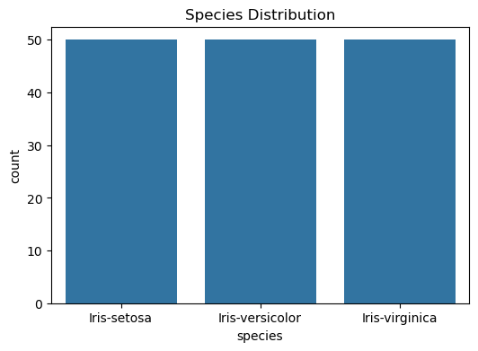
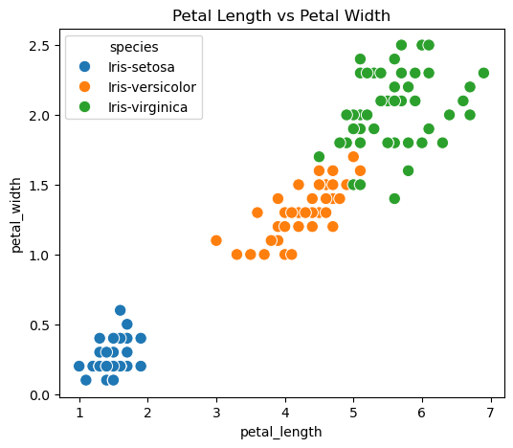
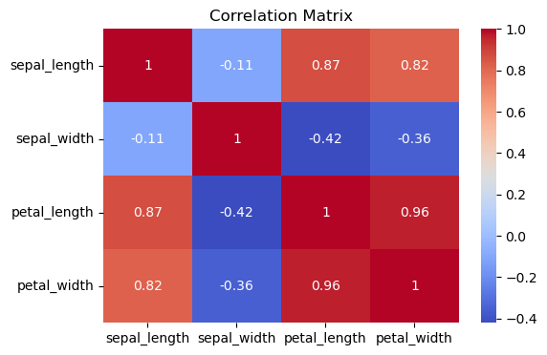

Accuracy: 1.0

Confusion Matrix:
[[10 0 0]
[ 0 9 0]
[ 0 0 11]]

Classification Report:
precision recall f1-score support

Iris-setosa 1.00 1.00 1.00 10
Iris-versicolor 1.00 1.00 1.00 9
Iris-virginica 1.00 1.00 1.00 11

accuracy 1.00 30
macro avg 1.00 1.00 1.00 30
weighted avg 1.00 1.00 1.00 30

Feature Importance:
Feature Importance
2 petal_length 0.895406
3 petal_width 0.090107
1 sepal_width 0.014487
0 sepal_length 0.000000
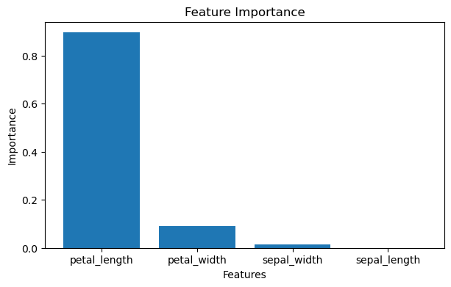

Prediction for New Flower:
Predicted Species: Iris-virginica

